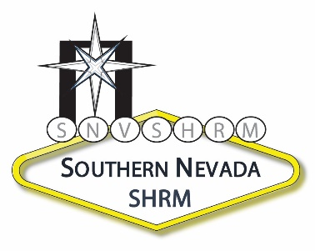 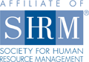

August 9, 2010

Concetta C. Bertussi, SPHR

Sr. HR Analyst/Business Partner

Konami Gaming, Inc.

585 Trade Center Drive

Las Vegas, Nevada 89119

Dear Connie,

I wanted to thank you for taking the time to speak at the Southern Nevada SHRM seminar on July 23, 2010. Your presentation on HR Metrics is highly relevant for those HR practitioners that want to make a more significant contribution to their company’s success. I believe performing these types of analyses can only benefit an organization, especially in this economy.

Thank you again for spending the day with us!

Sincerely,

Board Member Name

Board Position